|  |
| --- |
| **Sunsilk 5 Natural Oils** |
| **Property ID:**UA-32615935-25 |
| **Default URL:**http://ec2-23-20-8-70.compute-1.amazonaws.com/campaign/SG/sunsilk/ |

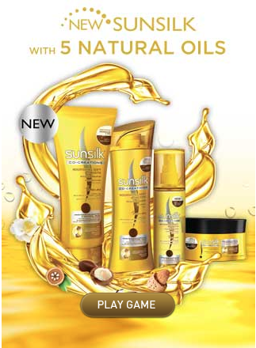

|  |  |  |
| --- | --- | --- |
| Item | Category | Action |
| 1 | Game | startgame |

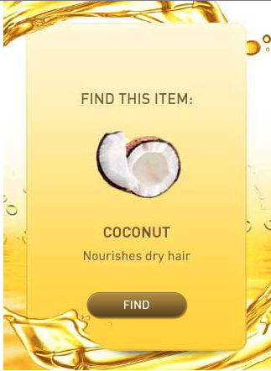

|  |  |  |
| --- | --- | --- |
| Item | Category | Action |
| 1 | Game | Q1 |

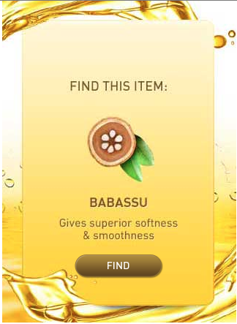

|  |  |  |
| --- | --- | --- |
| Item | Category | Action |
| 1 | Game | Q2 |

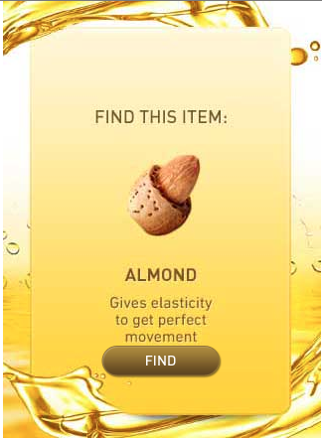

|  |  |  |
| --- | --- | --- |
| Item | Category | Action |
| 1 | Game | Q3 |

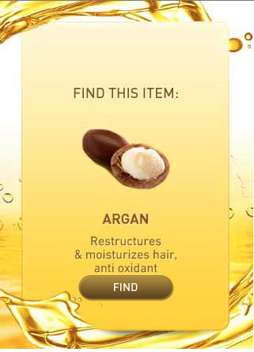

|  |  |  |
| --- | --- | --- |
| Item | Category | Action |
| 1 | Game | Q4 |

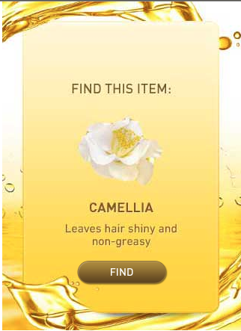

|  |  |  |
| --- | --- | --- |
| Item | Category | Action |
| 1 | Game | Q5 |

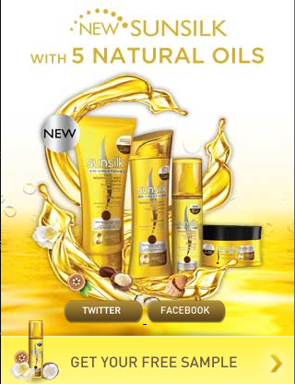

|  |  |  |
| --- | --- | --- |
| Item | Category | Action |
| 1 | Link | twitter |
| 2 | Link | Fb |
| 3 | Link | sampleproduct |